Collaboration across multiple service systems is central to the Strengthening Families approach. State and local leadership teams for Strengthening Families are made up of multiple agencies and partners, including community and parent leaders. Each represent a unique part of the systems of support that families need. Partnerships have developed because each partner can see a benefit of the Protective Factors to their own work with families, so they are willing to align resources and share leadership for planning and results. These leadership teams have demonstrated that Strengthening Families can be a powerful tool for helping separate elements of support join together as an effective

system to achieve outcomes for children and families.

As a comprehensive approach to working with families and not a model program, Strengthening Families is intended to be adapted to different contexts, programs and service systems. This allows each partner to apply the Protective Factors Framework within the context of their own work with children and families – whether that is domestic violence services, family child care, services for children with special needs or others. In addition, because Strengthening Families does not require new funding and can be implemented through low-cost and no-cost innovations, it has helped agencies shape existing resources around common goals. States with no new dollars to spend have built the Protective Factors Framework into existing contracts, requests for proposals, trainings or other vehicles already in place to shape and support collaborative practices.

Strengthening Families also supports family leadership, an arena that has often been a challenge for formal service systems. The Protective Factors Framework applies to all families and focuses on building strengths, which offers a positive starting point for family engagement. Program strategies built on the framework are intended to be adapted to the cultures, traditions and values of participating families, since Protective Factors are built and expressed differently in different contexts. Many tools and concrete examples for building parent leadership and engaging families as partners have been developed through Strengthening Families initiatives around the country.

Strengthening Families as a Platform for Collaboration

The Strengthening Families approach to collaboration, using the common language of research-based

Protective Factors to describe results for families across systems, has led to:

n Better understanding of the role that each service

system – both administrators and practitioners – plays in supporting families

n More effective partnerships among agencies and among individual workers

n A professional development system that fosters

collaboration by creating a common language and common approach across disciplines

nGreater appreciation for the significant role that non governmental community resources like informal networks, churches, social groups and cultural practices play in building protective factors with families

n Consistent, positive messages about building on

strengths that encourage family engagement and partnerships

n Greater cumulative impact on results for both children

and their families across systems

*35*

Center for the Study of Social Policy | 1575 Eye Street NW, Ste. 500 | Washington, DC 20005 | www.strengtheningfamilies.net | www.cssp.org

# Strengthening Families as a Platform for Collaboration

State leadership teams have used the Strengthening Families framework to show how all parts of a system are linked through efforts to build protective factors with families.

Diverse agencies and programs are responsible for specialized parts of the system, but all of them focus some aspect of their work on families. Their goals intersect in the need to create a strong partnership with families and to support the family’s role in promoting their children’s development.

The Protective Factors Framework combines familiar research findings that already guide policies and practices into a comprehensive approach to supporting families. The framework offers a

common language to describe what all families need regardless of which part of the system they touch: n Parental Resilience

n Social Connections

n Knowledge of Parenting and Child Development

n Concrete Support in Times of Need

n Social and Emotional Competence of Children

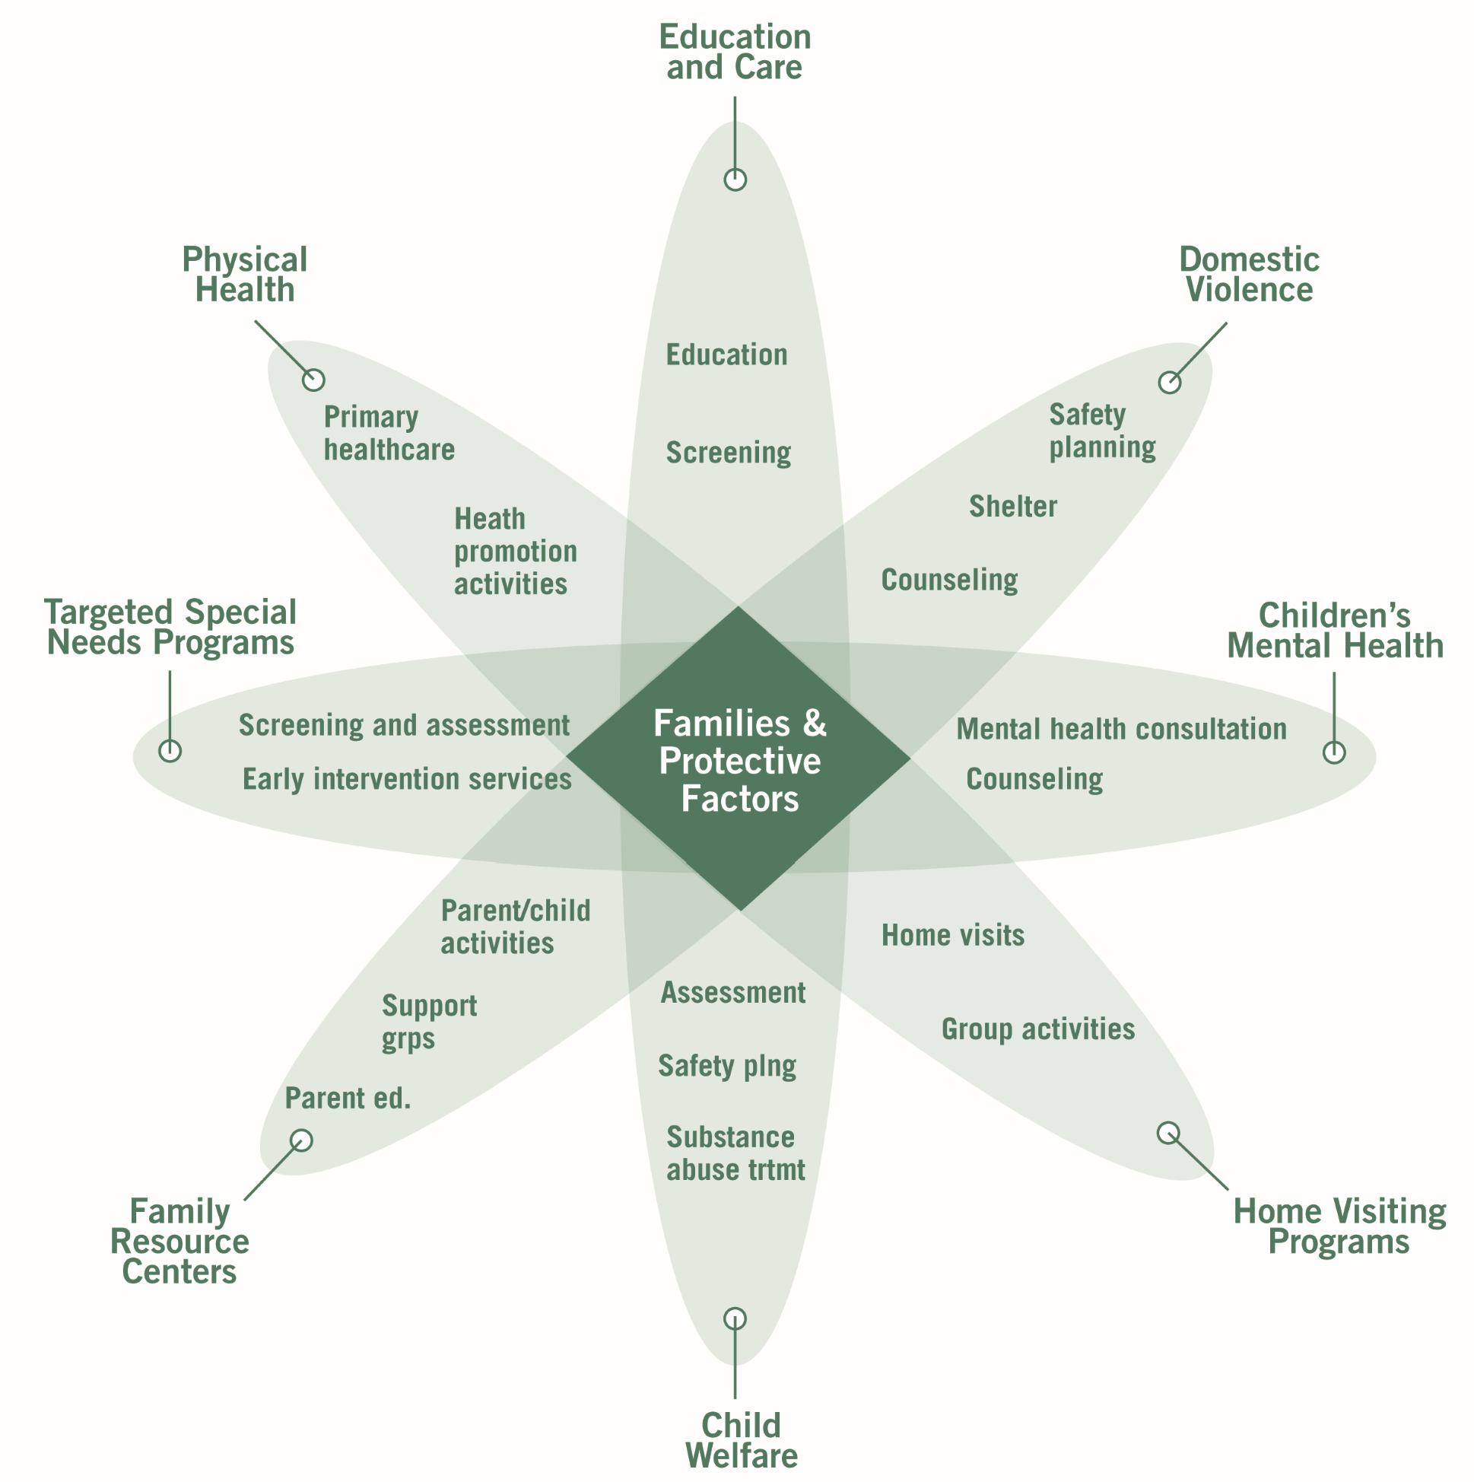

*36*